Sphere Rotational axis
# Source: AI Source: Provided by: [Data Path: Persons Table -> ID Column: 1, Name_En Column: Motasem Essam] -> From: [ChatGPT] on [7/25/2026]
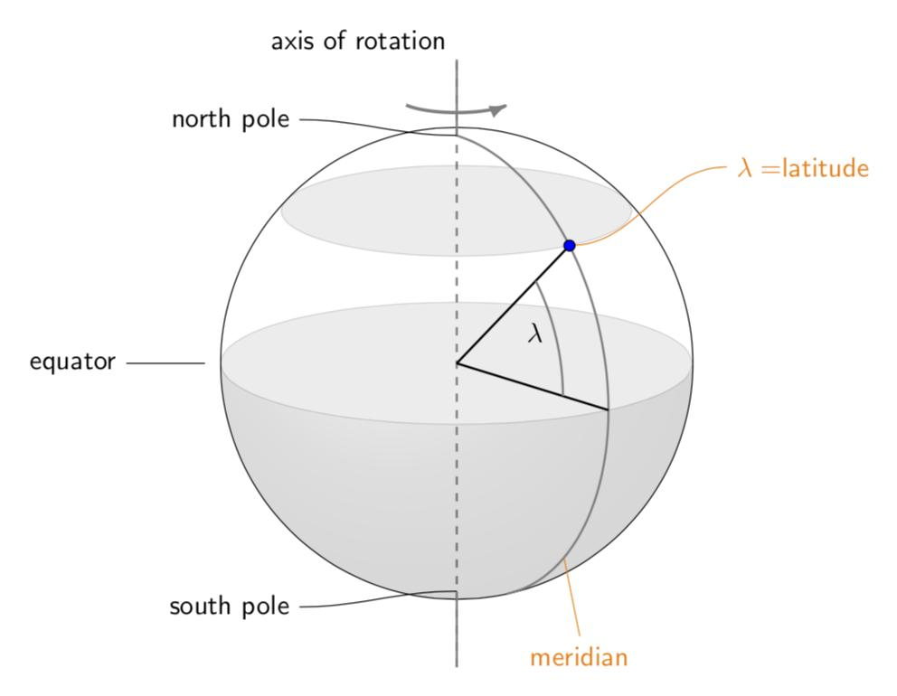
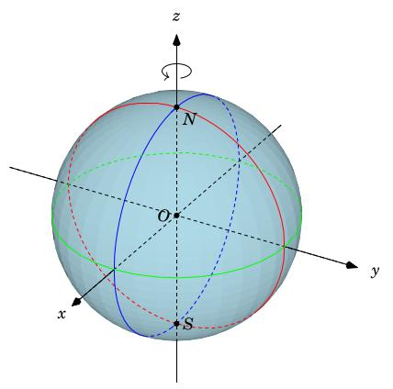
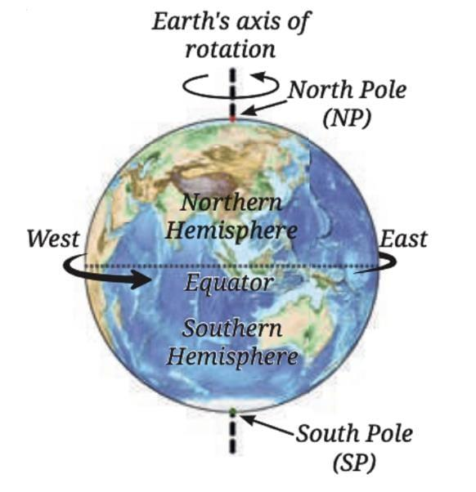

Definition
# Source: AI Source: Provided by: [Data Path: Persons Table -> ID Column: 1, Name_En Column: Motasem Essam] -> From: [ChatGPT] on [7/25/2026]
The rotational axis of a sphere is a straight line through the sphere's center about which the sphere rotates. For an ideal sphere, any line passing through its center can serve as an axis of rotation because the sphere's shape remains unchanged when rotated about that line.
For a rotating physical sphere, the rotational axis refers to the particular line about which it spins. For Earth, this is the line passing through the North Pole and South Pole, approximately.

Simple Definition
# Source: AI Source: Provided by: [Data Path: Persons Table -> ID Column: 1, Name_En Column: Motasem Essam] -> From: [ChatGPT] on [7/25/2026]
A sphere's rotational axis is an imaginary straight line through its center around which the sphere spins.

Geometric Representation
# Source: AI Source: Provided by: [Data Path: Persons Table -> ID Column: 1, Name_En Column: Motasem Essam] -> From: [ChatGPT] on [7/25/2026]
Consider a sphere with center $O$ and radius $R$. Its rotational axis passes through the center and intersects the spherical surface at two opposite points.
- Center: $O$, the midpoint of the sphere's diameter along the axis.
- Rotational axis: The straight line through the center.
- Poles: The two points where the selected axis intersects the sphere's surface.
- Equatorial plane: A plane through the center perpendicular to the rotational axis.
- Equatorial great circle: The circle formed by the intersection of the equatorial plane and the sphere's surface.
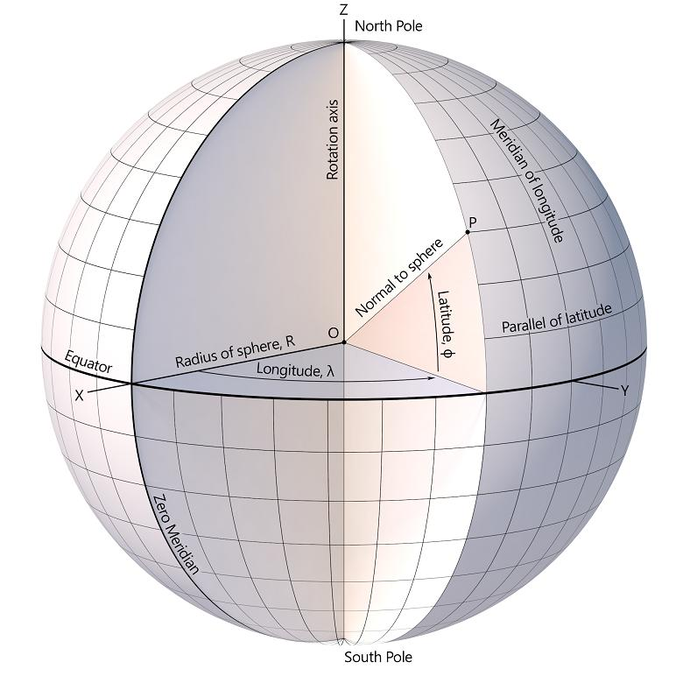
Important: A perfect sphere has no unique rotational axis determined by its shape alone. The physical motion or chosen reference orientation determines which axis is used.

Mathematical Representation
# Source: AI Source: Provided by: [Data Path: Persons Table -> ID Column: 1, Name_En Column: Motasem Essam] -> From: [ChatGPT] on [7/25/2026]
Suppose a sphere has center $O=\left(0,0,0\right)$ and radius $R$, and its rotational axis is the $z$-axis.
The sphere equation is
$$x^{2}+y^{2}+z^{2}=R^{2}$$
The rotational axis is described by
$$\boxed{x=0, y=0}$$
or equivalently,
$$\boxed{\left(x,y,z\right)=\left(0,0,t\right), t∈R}$$
The axis intersects the sphere at its two poles:
$$\boxed{N=\left(0,0,R\right)}$$
$$\boxed{S=\left(0,0,-R\right)}$$
The distance between these poles is the diameter:
$$\boxed{NS=2R}$$

Key Characteristics
# Source: AI Source: Provided by: [Data Path: Persons Table -> ID Column: 1, Name_En Column: Motasem Essam] -> From: [ChatGPT] on [7/25/2026]
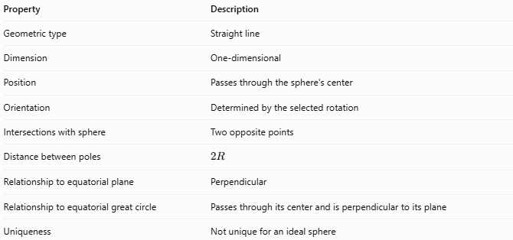
Property | Description
Geometric type | Straight line
Dimension | One-dimensional
Position | Passes through the sphere's center
Orientation | Determined by the selected rotation
Intersections with sphere | Two opposite points
Distance between poles | $$2R$$
Relationship to equatorial plane | Perpendicular
Relationship to equatorial great circle | Passes through its center and is perpendicular to its plane
Uniqueness | Not unique for an ideal sphere

Worked Example
# Source: AI Source: Provided by: [Data Path: Persons Table -> ID Column: 1, Name_En Column: Motasem Essam] -> From: [ChatGPT] on [7/25/2026]
Problem: A sphere has a radius of $5\text{ cm}$, is centered at the origin, and rotates about the $z$-axis. Find its rotational axis, poles, and distance between the poles.
Step 1 — Rotational axis
$$\boxed{x=0, y=0}$$
Step 2 — Locate the poles
The poles lie on the sphere where $x=y=0$.
Substitute into the sphere equation:
$$z^{2}=25$$
Therefore,
$$\boxed{N=\left(0,0,5\right)}$$
$$\boxed{S=\left(0,0,-5\right)}$$
Step 3 — Calculate the distance between the poles
$$NS=5-\left(-5\right)$$
$$\boxed{NS=10\text{ cm}}$$
The pole-to-pole distance equals the sphere's diameter.

Rotational Axis vs. Related Concepts
# Source: AI Source: Provided by: [Data Path: Persons Table -> ID Column: 1, Name_En Column: Motasem Essam] -> From: [ChatGPT] on [7/25/2026]
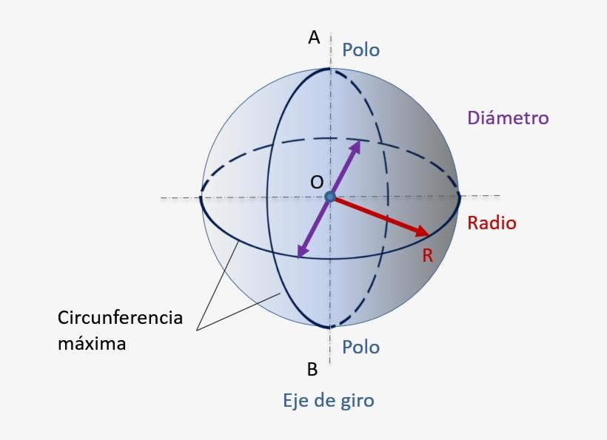
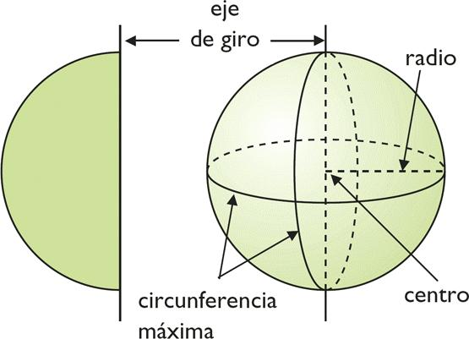
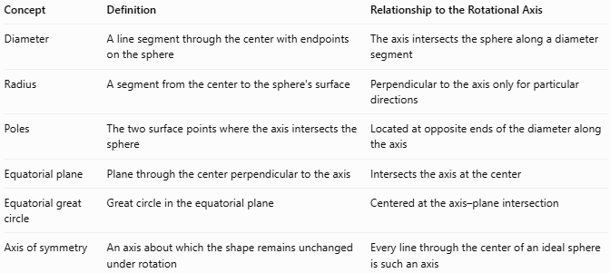
Concept | Definition | Relationship to the Rotational Axis
Diameter | A line segment through the center with endpoints on the sphere | The axis intersects the sphere along a diameter segment
Radius | A segment from the center to the sphere's surface | Perpendicular to the axis only for particular directions
Poles | The two surface points where the axis intersects the sphere | Located at opposite ends of the diameter along the axis
Equatorial plane | Plane through the center perpendicular to the axis | Intersects the axis at the center
Equatorial great circle | Great circle in the equatorial plane | Centered at the axis–plane intersection
Axis of symmetry | An axis about which the shape remains unchanged under rotation | Every line through the center of an ideal sphere is such an axis

Applications
# Source: AI Source: Provided by: [Data Path: Persons Table -> ID Column: 1, Name_En Column: Motasem Essam] -> From: [ChatGPT] on [7/25/2026]
- Astronomy: Describing the rotation of planets, stars, and other approximately spherical bodies.
- Geography: Defining Earth's poles, equator, and rotational reference system.
- Physics: Studying angular velocity, angular momentum, and rotational motion.
- Engineering: Modeling rotating spherical components and spherical mechanisms.
- Computer graphics: Defining the direction of rotation of a spherical object.

Key Points
# Source: AI Source: Provided by: [Data Path: Persons Table -> ID Column: 1, Name_En Column: Motasem Essam] -> From: [ChatGPT] on [7/25/2026]
- A sphere's rotational axis is a straight line through its center.
- It represents the line about which the sphere spins.
- It intersects the spherical surface at two opposite points called poles.
- The distance between the poles is $2R$.
- The equatorial plane is perpendicular to the rotational axis.
- A perfect sphere has infinitely many possible rotational axes; a particular rotation selects one.

Conclusion
# Source: AI Source: Provided by: [Data Path: Persons Table -> ID Column: 1, Name_En Column: Motasem Essam] -> From: [ChatGPT] on [7/25/2026]
The sphere rotational axis is the line through a sphere's center about which it rotates. It determines the positions of the poles and the orientation of the equatorial plane. Although an ideal sphere's geometry does not favor any particular axis, the axis becomes significant when describing the rotation of physical objects such as Earth, planets, and spherical mechanisms.

